How to save a draft of your answers:
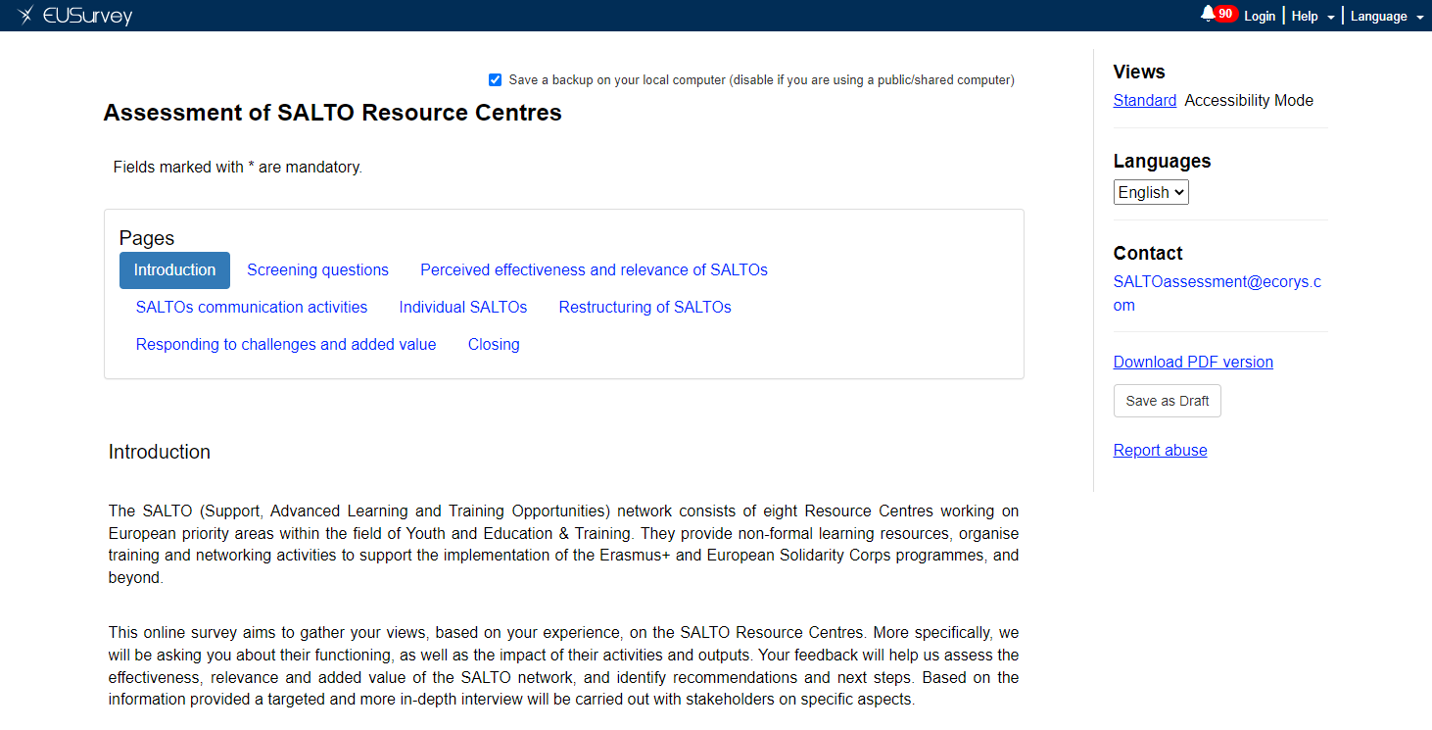
If you want to save your answers to the survey so that you can access it and complete it in a second moment, you can do so by clicking the ‘Save the draft’ button on the right side of the page.
You will be redirected automatically to the page below, where you will receive a new link to access your answers and continue the survey. You will have the option to send the new link via e-mail or copy it, and you can also download a PDF version of your draft answers.
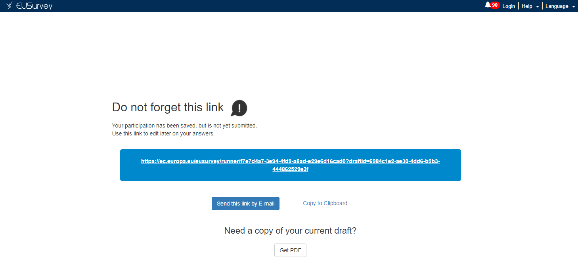

If you have any issues, please contact us at SALTOassessment@ecorys.com.

